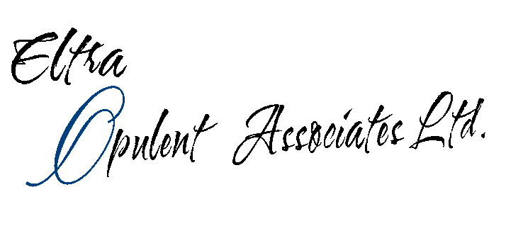

Eltra Opulent Associates Ltd.
Consultancy Operating Guidelines for Clients & Prospects.

- We contact, introduce ourselves to potential clients or prospects.
- Via phone, fax or email.

- We request a meeting to discuss how we can assist the potential client/prospect to achieve their company goal/objective as it pertains to services we offer. We provide an introductory letter with a fact-finding questionnaire to determine whether such a meeting is required.

- Once meeting is secured, we acquire initial information via a free consultation with decision maker(s). There is a presentation overview of our company (via Ppt or verbally). At the second meeting, we provide you with a consultation questionnaire.

- We discuss a more detailed overview of your project (the relationship – your expectations, concerns, budget constraints, etc.), successful outcomes, importance of risk management and evaluation processes, or your intended activity (e.g. conference, etc).

- We discuss the costing of projects after confirmation is given for an RFP to be submitted.

- We negotiate a workable pricing package and any contractual arrangements required.

